**5**

**The Laws of Motion**

|  |
| --- |
| **CHAPTER OUTLINE** |

5.1 The Concept of Force

5.2 Newton’s First Law and Inertial Frames

5.3 Mass

5.4 Newton’s Second Law

5.5 The Gravitational Force and Weight

5.6 Newton’s Third Law

5.7 Analysis Models Using Newton’s Second Law

5.8 Forces of Friction

\* An asterisk indicates a question or problem new to this edition.

|  |
| --- |
| **SOLUTIONS TO THINK-PAIR-SHARE AND ACTIVITIES** |

**\*TP5.1 Conceptualize** Imagine the situation occurring: The car is moving up the hill and suddenly the brakes are slammed on, locking the wheels. The car slows down due to two effects: the kinetic friction force on the wheels, and a component of the gravitational force acting down the hill. Because the wheels are locked, the car leaves a nice, long evidential trail of its motion on the street: the skid mark. We will assume that we can distinguish the skid marks from the front tires from those of the rear, so we do not need to know the distance between the front and rear wheels. Either set of skid marks is 17.0 m long. Let’s make a drawing of the situation:

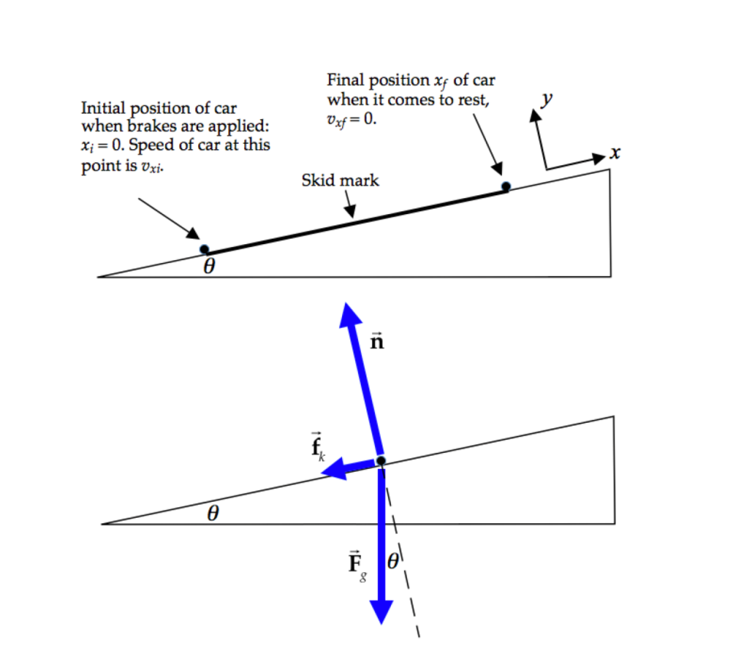

The upper drawing shows the kinematic information, while the lower drawing is a free-body diagram for the car during its motion.

**Categorize** The car is subject to forces and exhibits a change in its motion, so we use the *particle under a net force* model for the *x* direction, parallel to the incline, and the *particle in equilibrium* model perpendicular to the incline. We also know that the forces on the car are constant, resulting in a constant acceleration, so we will use the *particle under constant acceleration* model.

**Analyze** (a)From the particle under a net force and particle in equilibrium models, write equations for Newton’s second law in the *x* and *y* directions, that is, parallel and perpendicular to the plane:



In Equation (1), *m* is the combined mass of the driver and the car. We can also use our standard model for kinetic friction forces to relate the friction force on the car and the normal force on it:

 (3)

Combine Equations (1) through (3), eliminating *fk* and *n*, leading to

 (4)

Now, the gravitational force is *Fg* = *mg*, where, again, *m* is the combined mass of the driver and the car. Making this substitution, Equation (4) becomes

 (5)

This is the constant acceleration of the car. Now, from the particle under constant acceleration model, choose the equation relating velocity and position, Equation 2.17:



Incorporate the initial position and the final velocity, and solve for the initial speed of the car:

 (6)

Substitute the acceleration from Equation (5) into Equation (6):

 (7)

Substitute numerical values:



(b) This initial speed of the car exceeds the posted speed limit by over 50%, so your group should *not* agree to offer testimony for the defense in this case.

**Finalize** Notice what data we did *not* need for a solution: the mass of the car, the mass of the driver, and the coefficient of static friction.

*Answer:* (a) no (b) The initial speed of the car exceeds the posted speed limit.

**\*TP5.2 Conceptualize** Imagine throwing the egg so that it follows a trajectory like that in Figure 4.8. When the egg lands in your hand, it will be brought to rest over a short distance if you hold your hand stationary. You may be tempted to think that it is brought to rest over zero distance, but two things happen to provide some distance. One, your hand is soft, so the flesh of your hand will compress a bit when the egg hits it. More importantly, experience shows us that the egg breaks in this situation, so the egg will be brought to rest over a distance comparable to its diameter as the leading edge stops and parts of the egg behind the leading edge continue to move. When you move your hands backward while catching the egg, the stopping distance is increased significantly.

**Categorize** The analysis involves a combination of a trajectory problem for the thrown egg and a *particle under a net force* as the egg is brought to rest. Without more detailed knowledge, and since we are making an estimate, let’s assume that the acceleration of the egg is constant as it is brought to rest by the hand, so we can use the *particle under constant acceleration* model.

**Analyze** In a typical egg-throwing contest, there is no fixed separation between the thrower and the catcher, because the game is often played by starting with the participants close together, and then moving apart as successful transfers are made, until the egg breaks. Let us choose a separation distance of 10 m as a possibility. Assume the egg is thrown at 45° and returns to the same height from which it is thrown. We can then use Equation 4.20 to find the speed with which the egg is thrown, which is the same as the speed with which it lands in the hand:

 (1)

where *R* = 10 m is the range of the egg toss. Now, let’s focus on the egg. A medium egg has a mass of about 50 g = 0.050 kg. A typical diameter might be 40 mm = 0.040 m. When the hand is held stiffly, the egg will be brought to rest over a distance similar to its diameter. When the hand moves backward while catching the egg, the egg will be brought to rest over a longer distance, lets say, 1.0 m.

From the particle under constant acceleration model, let’s find the acceleration of the egg as it is brought to rest. Assume that the direction of this acceleration is opposite that of the final velocity vector of the egg at the end of its flight, which we will call the *s* direction. Then, using Equation 2.17,

 (2)

where *d* is the distance over which the egg is brought to rest (*vsf* = 0). The initial speed *vsi* in Equation (2) for the acceleration portion of the motion is the same as the final speed *vf* for the trajectory found above in Equation (1). From the particle under a net force model, the force exerted on the egg while it is brought to rest is

 (3)

Combining Equations (1), (2), and (3), we have the force on the egg in terms of estimated values:



Substituting numerical values for the egg caught in the stiffly held hand,



For the egg caught in the hand that moves backward while catching it,



**Finalize** Therefore, with these estimates and assumptions, the magnitude of the force on the egg is reduced by a factor of 25 by moving the hands backward while catching the egg.

*Answer:* Answers will vary, based on estimates.

**\*TP5.3** *Answers:* (a) The coefficient of static friction is given by the equation in Example 5.11, , where *c* is the critical angle. Answers will vary, depending on the coin and the condition of the book cover. (b) Ideally, the coefficient should not depend on the number of coins.

|  |
| --- |
| **SOLUTIONS TO END-OF-CHAPTER PROBLEMS** |

**Section 5.1 The Concept of Force**

**P5.1** Using the reference axes shown in Figure P5.4, we see that



and



Thus, the magnitude of the resultant force exerted on the tooth by the wire brace is



or



**P5.2** (a) 

(b) 

(c) 

(d) 

(e) 

(f) 

**Section 5.4 Newton’s Second Law**

**P5.3** We use Newton’s second law to find the force as a vector and then the Pythagorean theorem to find its magnitude. The givens are *m* = 3.00 kg and 

(a) The total vector force is



(b) Its magnitude is



**P5.4** (a) Let the *x* axis be in the original direction of the molecule’s motion. Then, from  we have



(b) For the molecule,  Its weight is negligible.



**P5.5** (a) We start from the sum of the two forces:



The acceleration is then:



and the velocity is found from





(b) The direction of motion makes angle *θ* with the *x* direction.





(c) Displacement:

*x*-displacement 

*y*-displacement 



(d) Position: 



**P5.6** Since the two forces are perpendicular to each other, their resultant is



at an angle of



From Newton’s second law,



or



**P5.7**  reads



where  represents the direction of 



 at  below the –x axis



For the vectors to be equal, their magnitudes and their directions must be equal.

(a) Therefore  counter-clockwise from the x axis

(b) 

(c) 

(d) 



So, 

**P5.8**  implies the acceleration is given by



Then the total force is



The resistive force is opposite to the velocity:



**P5.9** We find the mass of the baseball from its weight: w = mg, so m = w/g = 2.21 N/9.80 m/s2 = 0.226 kg.

(a) We use  and  with *v*i = 0,   
*v*f = 18.0 m/s, and 



(b) We solve for acceleration using  which gives



where a is in m/s2, v is in m/s, and t in s. Substituting gives



Call **** = force of pitcher on ball, and  = force of Earth on ball (weight). We know that



Writing this equation in terms of its components gives

 

 

Solving,



Then,



and 



**Section 5.5 The Gravitational Force and Weight**

**P5.10** (a) Use  where *vi* = 0, *vf* = *v*, and 



(b) Use *vxf* = *vxi* + *axt*:



Call **** = force of pitcher on ball, and = gravitational force on ball. We know that



writing this equation in terms of its components gives

 

 

Solving and substituting from above,

*F*1*x* = *mv*/*t* *F*1*y* = *mg*

then the magnitude of *F*1 is



and its direction is



**P5.11** Since this is a linear acceleration problem, we can use Newton’s second law to find the force as long as the electron does not approach relativistic speeds (as long as its speed is much less than 3 × 108 m/s), which is certainly the case for this problem. We know the initial and final velocities, and the distance involved, so from these we can find the acceleration needed to determine the force.

(a) From  we can solve for the acceleration and then the force: 

Substituting to eliminate *a*, 

Substituting the given information,





(b) The Earth exerts on the electron the force called weight,



The accelerating force is



**P5.12** We are given, from which we can find the man’s mass,



Then, his weight on Jupiter is given by



**P5.13** (a) You and the Earth exert equal forces on each other: *my g* = *ME aE*. If your mass is 70.0 kg,

 **[1]**

(b) You and the planet move for equal time intervals  according to . If the seat is 50.0 cm high,





We substitute for  from [1] to obtain





**Section 5.6 Newton’s Third Law**

**P5.14** The free-body diagrams are shown in ANS. FIG. P5.14 below.

(a) 

(b) 

**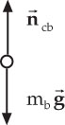 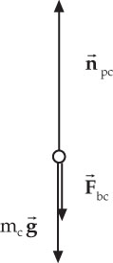** brick cushion  
 (a) (b)

**ANS. FIG.P5.14**

(c) 

**Section 5.7 Analysis Models Using Newton’s Second Law**

**P5.15** As the worker through the pole exerts on the lake bottom a force of 240 N downward at 35° behind the vertical, the lake bottom through the pole exerts a force of 240 N upward at 35° ahead of the vertical. With the x axis horizontally forward, the pole force on the boat is

****

The gravitational force of the whole Earth on boat and worker is *Fg* = *mg* = 370 kg (9.8 m/s2) = 3 630 N down. The acceleration of the boat is purely horizontal, so

 gives +*B* + 197 N – 3 630 N = 0

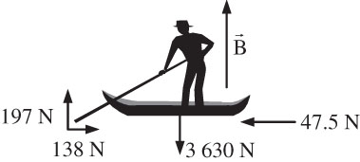 (a) The buoyant force is .

(b) The acceleration is given by



**ANS. FIG. P5.15**



According to the constant-acceleration model,

**ANS. FIG. P5.16(a)**

**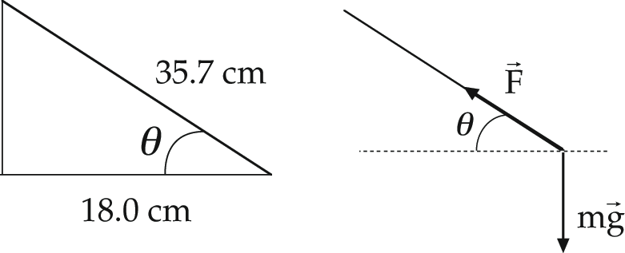P5.16** (a) The left-hand diagram in ANS. FIG. P5.16(a) shows the geometry of the situation and lets us find the angle of the string with the horizontal:

cos*θ* = 28/35.7 = 0.784

or *θ* = 38.3°

The right-hand diagram in ANS. FIG. P5.16(a) is the free-body diagram. The weight of the bolt is

w = mg = (0.065 kg)(9.80 m/s2) = 0.637 N

(b) To find the tension in the string, we apply Newton’s second law in the *x* and *y* directions:

 **[1]**

 **[2]**

from equation [2],



(c) Now, from equation [1],





**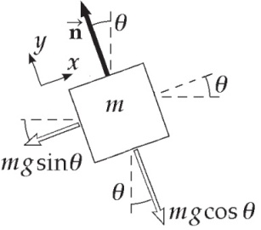P5.17** (a) ANS. FIG. P5.17(a) shows the forces on the   
object. The two forces acting on the block are   
the normal force, n, and the weight, mg. If   
the block is considered to be a point mass   
and the x axis is chosen to be parallel to the   
plane, then the free-body diagram will be as   
shown in the figure to the right. The angle   
*θ* is the angle of inclination of the plane.   
Applying Newton’s second law for the   
accelerating system (and taking the direction up the plane as the positive x direction), we have

**ANS. FIG. P5.17(a)**

: *n* = *mg* cos*θ*

: *a* = –*g* sin*θ*

(b) When **



(c) Starting from rest,



**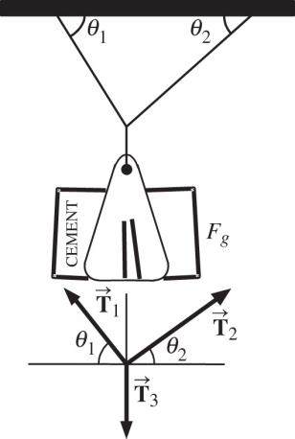P5.18** From equilibrium of the sack:

*T*3 = *Fg* **[1]**

From  for the knot:

 **[2]**

From  for the knot:

 **[3]**

**ANS. FIG. P5.18**

Eliminate *T*2 by using    
and solve for *T*1:

**P5.19** We use Newton’s second law with the forces in the *x* and *y* directions in equilibrium.

(a) At the point where the bird is perched, the wire’s midpoint, the forces acting on the wire are the tension forces and the force of gravity acting on the bird. These forces are shown in ANS. FIG. P5.19 below.

**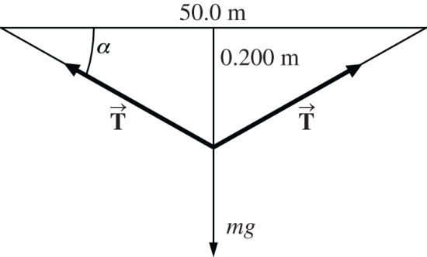**

**ANS. FIG. P5.19**

(b) The mass of the bird is *m* = 1.00 kg, so the force of gravity on the bird, its weight, is *mg* = (1.00 kg)(9.80 m/s2) = 9.80 N. To calculate the angle  in the free-body diagram, we note that the base of the triangle is 25.0 m, so that



Each of the tension forces has *x* and *y* components given by



The *x* components of the two tension forces cancel out. In the *y* direction,



which gives



**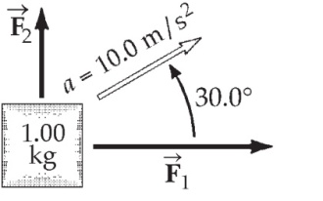P5.20** Choose a coordinate system with  East and  North. The acceleration is



**ANS. FIG. P5.20**

From Newton’s second law,



and 

So the force we want is



**:Art:Chapter 04 art:P04_23.epsP5.21** (a) Assume the car and mass accelerate horizontally. We consider the forces on the suspended object.

 

 

Substitute  from the first equation into the second,

**ANS. FIG. P5.21**





(b) 

**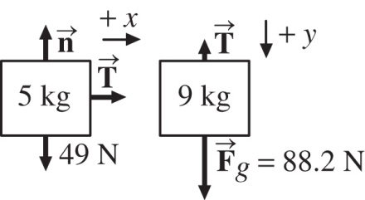P5.22** (a) The forces on the objects are shown in ANS. FIG. P5.22.

(b) and (c) First, consider *m*1, the block moving along the horizontal. The only force in the direction of movement is T. Thus,

**ANS. FIG. P5.22**



or *T* = (5.00 kg)*a* **[1]**

Next consider *m*2, the block that moves vertically. The forces on it are the tension T and its weight, 88.2 N.

We have 

88.2 N – *T* = (9.00 kg)*a* **[2]**

Note that both blocks must have the same magnitude of acceleration. Equations [1] and [2] can be added to give 88.2 N = (14.0 kg)*a*. Then



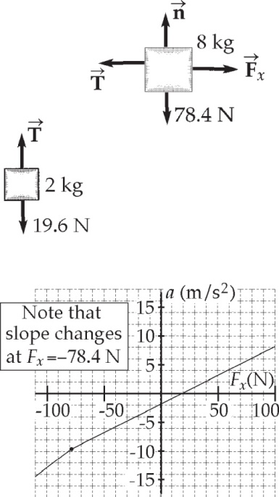**P5.23** Forces acting on m1 = 2.00-kg block:

*T* – *m*1*g* = *m*1*a* **[1]**

Forces acting on m2 = 8.00-kg block:

*Fx* – *T* = *m*2*a* **[2]**

(a) Eliminate T and solve for a:





**ANS. FIG. P5.23**

(b) Eliminate a and solve for T:





Note that if *Fx* < –*m*2*g*, the cord is loose, so mass m2 is in free fall and mass m1 accelerates under the action of Fx only.

(c) See ANS. FIG. P5.23.

|  |  |  |  |  |  |  |
| --- | --- | --- | --- | --- | --- | --- |
| Fx, N | –100 | –78.4 | –50.0 | 0 | 50.0 | 100 |
| ax, m/s2 | –12.5 | –9.80 | –6.96 | –1.96 | 3.04 | 8.04 |

**P5.24** We assume the vertical bar is in compression, pushing up on the pin with force *A*, and the tilted bar is in tension, exerting force *B* on the pin at –50.0°.

:Art:Chapter 04 art:P04_31.eps 







**ANS. FIG. P5.24**





Positive answers confirm that



**P5.25** (a) Pulley P2 has acceleration a1.

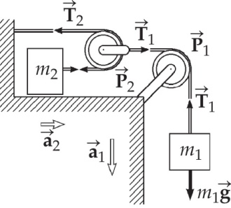Since m2 moves twice the distance P2 moves in the same time, m2 has twice the acceleration of P2, i.e., .

(b) From the figure, and using



**ANS. FIG. P5.25**

Equation [1] becomes *m*1*g* – 2*T*2 = *m*1*a*1. This equation combined with equation [2] yields



 and 

(c) From the values of T2 and T1, we find that

 and 

**Section 5.8 Forces of Friction**

**P5.26** Find the acceleration of the car, which is the same as the acceleration of the book because the book does not slide.

For the car: vi = 72.0 km/h = 20.0 m/s, vf = 0, ∆x = (xf  – *x*i) = 30.0 m. Using vf2 = vi2 + 2a(xf – xi), we find the acceleration of the car:

a = –6.67 m/s2

Now, find the maximum acceleration that friction can provide. Because the book does not slide, static friction provides the force that slows down the book. We have the coefficient of static friction, *μ*s = 0.550, and we know fs ≤ *μ*sn. The book is on a horizontal seat, so friction acts in the horizontal direction, and the vertical normal force that the seat exerts on the book is equal in magnitude to the force of gravity on the book:   
n = Fg = mg. For maximum acceleration, the static friction force will be a maximum, so fs = *μ*sn = *μ*smg. Applying Newton’s second law, we find the acceleration that friction can provide for the book:



–fs = *ma*

–*μ*smg = ma

which gives a = –*μ*s g = –(0.550)(9.80 m/s2) = –5.39 m/s2, which is too small for the stated conditions.



**P5.27** If the load is on the point of sliding   
forward on the bed of the slowing   
truck, static friction acts backward   
on the load with its maximum value,   
to give it the same acceleration as the   
truck:

ANS. FIG.P5.26



 

 

Solving for the normal force and substituting into the *x* equation gives:

 or 

We can then use



Which becomes



(a) 

(b) From the expression ,



**P5.28**  We assume that all the weight is on the rear wheels of the car.

1. We find the record time from

*F* = *ma*: *μ*s*mg* = *ma* or *a = μ*s*g*

But



so 



(b) 

**P5.29** Newton’s second law for the 5.00-kg mass gives

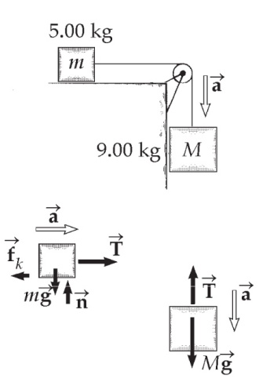 *T* – *fk* = (5.00 kg)*a*

Similarly, for the 9.00-kg mass,

(9.00 kg)*g* – *T* = (9.00 kg)*a*

Adding these two equations gives:



ANS. FIG.P5.29

Which yields *a* = 5.60 m/s2. Plugging this into   
the first equation above gives



**P5.30** The free-body diagrams for this problem are shown in ANS. FIG. P5.62.

:Art:Chapter 05 art:P05_04.eps

Free-Body Diagram Free-Body Diagram

of Person of Crutch Tip

**ANS.FIG. P5.30**

From the free-body diagram for the person,



which gives  Then,  yields *F* = 45.8 lb.

(a) Now consider the free-body diagram of a crutch tip.



or *f* = 17.2 lb.



which gives 

For minimum coefficient of friction, the crutch tip will be on the verge of slipping, so  and



(b) As found above, the compression force in each crutch is

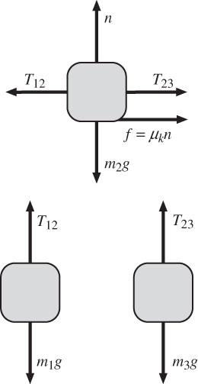 

**P5.31** (a) The free-body diagrams for each object appear on the right.

(b) Let a represent the positive magnitude of the acceleration  of m1, of the acceleration  of m2, and of the acceleration  of m3. Call T12 the tension in the left cord and T23 the tension in the cord on the right.

**ANS. FIG. P5.64(a)**

For m1, 



For m2, 



and , giving 

For m3, , giving 

We have three simultaneous equations:



Add them up (this cancels out the tensions):





(c) Now 



and 



(d) If the tabletop were smooth, friction disappears (*μ*k = 0), and so the acceleration would become larger. For a larger acceleration, according to the equations above, the tensions change:





**\*P5.32** Maximum static friction provides the force that produces maximum acceleration, resulting in a minimum time interval to accelerate through  = 3.00 m. We know that the maximum force of static friction is fs = *μ*sn. If the shoe is on a horizontal surface, friction acts in the horizontal direction. Assuming that the vertical normal force is maximal, equal in magnitude to the force of gravity on the person, we have n = Fg = mg; therefore, the maximum static friction force is

fs = *μ*sn = *μ*smg

Applying Newton’s second law:



fs = ma

**

We find the time interval  = t to accelerate from rest through = 3.00 m using 



(a) For *μ*s = 0.500, = 

(b) For *μ*s = 0.800, = 

**\*P5.33 Conceptualize** Imagine beginning from rest and suddenly running across the floor. If the coefficient of static friction is too low, your feet will slip and you will not be able to move away rapidly enough in an emergency. You want your feet to stay planted on the floor in order to give your body as large an acceleration as possible.

**Categorize** The problem statement suggests assuming that you be modeled as a *particle under constant acceleration*. You are also a *particle under a net force,* where the force of static friction between your feet and the floor is causing your acceleration.

**Analyze** Modeling your body of mass *m* as a particle under a net force, we have, in the horizontal direction,

*Fx* = *max* → *fs,*max = *max*

where we have recognized that the only force on your body in the horizontal direction is the force of static friction and we have assumed an impending motion situation where your foot is just about to slip. In this case, we can relate the friction force to the normal force on your body:

*fs,*max = *max* → *μsn* = *max*

Because your body is not accelerating in the vertical direction, it is a particle in equilibrium for this direction and the normal force is equal to your weight:

 (1)

Now, let’s model your body as a particle under constant acceleration in order to determine the acceleration *ax*. From Equation 2.16,

 (2)

Substituting Equation (2) into Equation (1), we have



Substituting numerical values,



Your shoes do qualify because the coefficient of static friction is larger than 0.5.

**Finalize** Though we have made numerous simplifications in modeling the interactions of a shoe sole with the tile floor during a run, the fact remains that the forward acceleration you experience is due entirely to the force of static friction between the soles of your shoes and the floor.

*Answer:* Yes, the coefficient of static friction is *s* ≈ 0.6, which is greater than regulated minimum value of 0.5.

**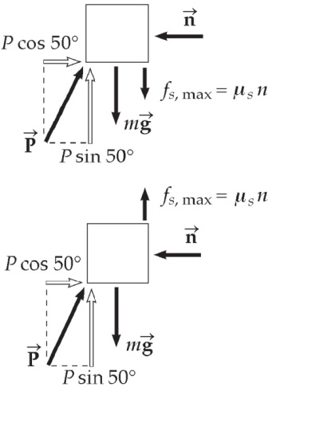P5.34** (a) To find the maximum possible value of P, imagine impending upward motion as case 1. Setting 



with 



Setting 

**ANS. FIG. P5.34**



To find the minimum possible value of P, consider impending downward motion. As in case 1,



Setting 



(b) 

(c) We repeat the calculation as in part (a) with the new angle.

Consider impending upward motion as case 1. Setting



Setting



The push cannot really be negative. However large or small it is, it cannot produce upward motion. To find the minimum possible value of P, consider impending downward motion. As in case 1,



Setting





**P5.35** The motion of the salmon as it breaks the surface of the water and eventually leaves must be modeled in two steps. The first is over a distance of 0.750 m, until half of the salmon is above the surface, while a constant force, *P*, is applied upward. In this motion, the initial velocity of the salmon as it nears the surface is 3.58 m/s and ends with the salmon having a velocity, *v*½, when it is half out of the water. This is then the initial velocity for the second motion, where gravity is a second force to be considered acting on the fish. This motion is again over a distance of 0.750 m, and results with the salmon having a final velocity of 6.26 m/s.

The vertical motion equations, in each case, would be



and



Solving for the square of the velocity in each case and equating the expressions, we find







In the first motion, the relationship between the net acceleration and the net force can be written as



Substituting from above,



In the second motion, the relationship between the net acceleration and the net force can be written as



Equating these two equations for, *P*,



Plugging into either of the above,



**P5.36** (a) The free-body diagrams are shown in the figure below.



**ANS. FIG. P5.36**

*f*1 and *n*1 appear in both diagrams as action-reaction pairs.

(b) For the 5.00-kg mass, Newton’s second law in the *y* direction gives:



In the *x* direction,





For the 10.0-kg mass, Newton’s second law in the *x* direction gives:



In the *y* direction,









**Additional Problems**

**P5.37** (a) Choose the black glider plus magnet as the system.





(b) The force of attraction the magnet exerts on the scrap iron is the same as in (a):



By Newton’s third law, the force the black glider exerts on the magnet is equal and opposite to the force exerted on the scrap iron:





**P5.38** Find the acceleration of the block according to the kinematic equations. The book travels through a displacement of 1.00 m in a time interval of 0.483 s. Use the equation  where 



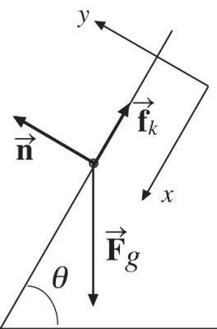 Now, find the acceleration of the block caused by the forces. See the free-body diagram below. We take the positive y axis is perpendicular to the incline; the positive x axis is parallel and down the incline.





ANS. FIG. P5.38





where 

Substituting the express for kinetic friction into the x-component equation gives



For *μ*k = 0.300, and  *a* = 7.02 m/s2.



**P5.39** (a) The free-body diagrams of the two blocks shown in ANS. FIG. P5.39(a):

**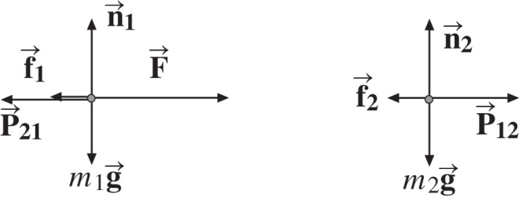**

**ANS. FIG. P5.39(a)**

Vertical forces sum to zero because the blocks move on a horizontal surface; therefore, ay = 0 for each block.

 

 

Kinetic friction is: Kinetic friction is:

 

(b) 

(c) 

(d) 

(e) The blocks are pushed to the right by force  so kinetic friction  acts on each block to the left. Each block has the same horizontal acceleration, ax = a. Each block exerts an equal and opposite force on the other, so those forces have the same magnitude:   
P12 = P21 = P.

 

F – *P* –f1 = m1a P – f2 = m2a

 

(f) Adding the above two equations of x components, we find



(g) From the x component equation for block 2, we have



We see that when the coefficients of friction are equal, *μ*1 = *μ*2, the magnitude P is independent of friction.

**P5.40** (a) Let *x* represent the position of the glider along the air track. Then ,  and . Now  is the rate at which the string passes over the pulley, so it is equal to  of the counterweight.



(b) 

At release from rest,  and .

(c) , 



For the counterweight, 





For the glider, 





**P5.41** (a) ANS. FIG. P5.41(a) shows the free-body diagrams for this problem.

Note that the same-size force *n* acts up on Nick and down on chair, and cancels out in the diagram. The same-size force *T* =   
250 N acts up on Nick and up on chair, and appears twice in the diagram.

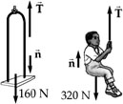 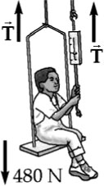

**ANS. FIG. P5.41(a)**

(b) First consider Nick and the chair together as the system. Note that **two** ropes support the system, and *T* = 250 N in each rope.

Applying  

where 

Solving for *a* gives 

(c) On Nick, we apply

 

where 

The normal force is the one remaining unknown:



Substituting, 

gives 

**P5.42** (a) free-body diagrams of block and rope are shown in ANS. FIG. P5.42(a):

**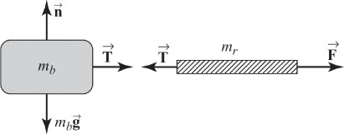**

**ANS. FIG. P5.42(a)**

(b) Applying Newton’s second law to the rope yields

 **[1]**

Then, applying Newton’s second law to the block, we find



which gives



(c) Substituting the acceleration found above back into equation [1] gives the tension at the left end of the rope as



or 

(d) From the result of (c) above, we see that as mr approaches zero, T approaches F. Thus,



**P5.43** (a) See free-body diagrams in ANS. FIG. P5.43.

(b) We write  for each object.

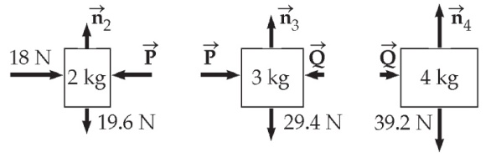 

**ANS. FIG. P5.43**

Adding gives



(c) The resultant force on any object is  All have the same acceleration:



(d) From above, P = 18 N – (2 kg)a → , and Q = (4 kg)a → 

(e) 

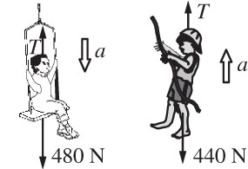**P5.44** See ANS. FIG. P5.44 showing the free-body   
diagrams. The rope has tension T.

(a) As soon as Nick passes the rope to   
the other child,

**ANS. FIG. P5.44**



On Nick and the seat,



On the child,



Adding,



The rope tension is *T* = 440 N + (44.9 kg)(0.426 m/s2) = 459 N.

(b) The rope must support Nick and the seat, so the rope tension is 480 N.



The tension in the chain supporting the pulley is 480 N + 480 N = 960 N, so the chain may break first.

**P5.45** (a) The crate is in equilibrium, just before it starts to move. Let the normal force acting on it be *n* and the friction force, fs.

Resolving vertically:  gives

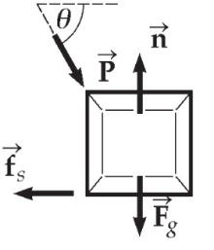 

Horizontally,  gives

P cos *θ* = f

**ANS. FIG. P5.45**

But,

**

i.e.,



or



Divide by cos *θ* :



Then



(b) 

**P5.46** (a) When block 2 moves down 1 cm, block 1 moves 2 cm forward, so block 1 always has twice the speed of block 2, and  relates the magnitudes of the accelerations.

(b) Let T represent the uniform tension in the cord.

For block 1 as object,

 [1]

For block 2 as object,

 [2]

To solve simultaneously we substitute equation [1] into equation [2]:



for m2 = 1.30 kg: 

(c) If m1 is very much less than 1.30 kg, a2 approaches

12.7 N/1.30 kg = 

(d) If m1 approaches infinity, 

(e) From equation (2) above, 2T = m2g + m2a2 = 12.74 N + 0, 

(f) 

**\*P5.47 Conceptualize**  Make sure you are clear on the physical setup of the problem. The ship is moving toward the reef with an initial velocity when the rudder jams. There is a force toward the reef from the wind and a force away from the reef due to the propellers. The question is this: Under the action of these forces, can the ship be reversed before it strikes the reef?

**Categorize** The ship is modeled as a *particle under a net force*. Because the forces are all constant, it is also modeled as a *particle under constant acceleration.*

**Analyze** From Equation 2.17 in the particle under constant acceleration model, solve for the final position of the boat:

 (1)

Let’s imagine that the reef is not there and simply find out how far the boat would move before coming to rest. If this distance is less than 900 m, the captain could have stopped before hitting the reef. If it is greater, the captain could not stop in time. We define the initial position of the boat when the rudder jams as *xi* = 0, and we set *vxf* = 0 to find out how far the boat moves before stopping. Therefore, Equation (1) becomes

 (2)

Now, use Newton’s second law in the particle under a net force model to substitute for the acceleration in Equation (2):



Substitute numerical values:



Under these conditions, the ship would require almost 1.5 km to come to rest if the reef were not there. Because the reef is only 900 m away, it was inevitable that the ship was going to hit the reef. There is nothing that the captain could have done to avoid the accident.

**Finalize** The actions of the captain did slow the ship so that the ship did not hit the reef as strongly, resulting in less damage to the cargo and fewer injuries to the crew. By putting the ship’s engines in reverse, the captain slowed down the ship so that it did not hit the reef as strongly. From Newton’s second law, the constant acceleration of the ship before it struck the reef was



At this rate of deceleration, the ship’s final velocity as it struck the reef, computed from Equation 2.17, was



Had the captain not reversed the engines, the ship would have increased its speed because

of the wind force and struck the reef at a much higher speed than 2.50 m/s.

*Answer:* Ship requires 1.5 km to come to rest.

**P5.48** (a) The net force on the cushion is in a fixed direction, downward and forward making angle *θ* = tan−1(F/mg) with the vertical.



(b) 

(c) Since the line of motion is in the direction of the net force, they both make the same angle with the vertical. Refer to Figure P5.91 in the textbook: in terms of a right triangle with angle *θ*, height h, and base x,



and the cushion will land a distance

x = 

(d) The cushion will move along a tilted parabola. If the cushion were experiencing a constant net force directed vertically downward (as is normal with gravity), and if its initial velocity were down and somewhat to the left, the trajectory would have the shape of a parabola that we would expect for projectile motion. Because the constant net force is “sideways”—at an angle *θ* counterclockwise from the vertical—the cushion would travel a similar trajectory as described above, but rotated counterclockwise by the angle *θ* so that the initial velocity is directed downward. See the figures.

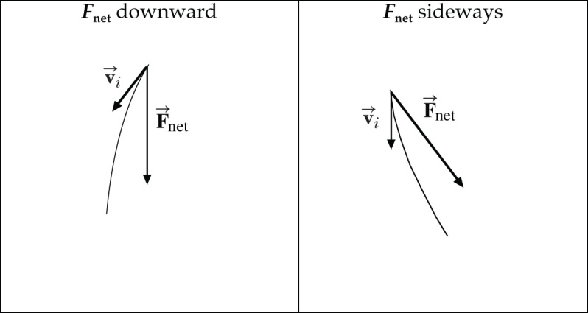

**ans. FIG. P5.48(d)**

**P5.49** We will use  on each object, so we draw force diagrams for the *M* + *m*1 + *m*2 system, and also for blocks *m*1 and *m*2. Remembering that normal forces are always perpendicular to the contacting surface, and always **push** on a body, draw *n*1 and *n*2 as shown. Note that *m*1 is in contact with the cart, and therefore feels a normal force exerted by the cart. Remembering that ropes always **pull** on bodies toward the center of the rope, draw the tension force  Finally, draw the gravitational force on each block, which always points downwards.

Applying 

**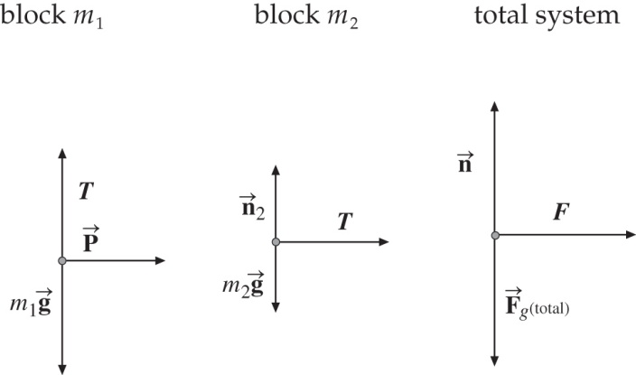** For m1: T –m1g = 0

For m2: T = m2a

Eliminating T,



For all three blocks:

**ANS. FIG. P5.49**



**P5.50** (a) 



or 

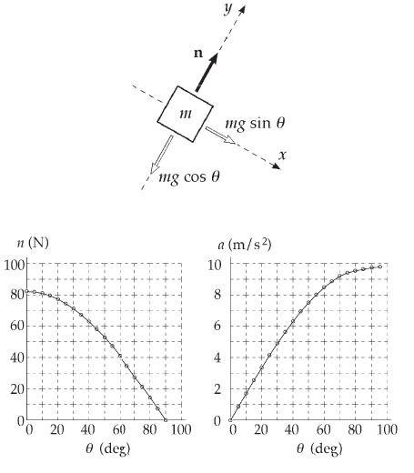 (b) 



or



**ANS. FIG. P5.50**

(c)

|  |  |  |
| --- | --- | --- |
| *θ*, deg | *n*, N | *a*, m/s2 |
| 0.00 | 82.3 | 0.00 |
| 5.00 | 82.0 | 0.854 |
| 10.0 | 81.1 | 1.70 |
| 15.0 | 79.5 | 2.54 |
| 20.0 | 77.4 | 3.35 |
| 25.0 | 74.6 | 4.14 |
| 30.0 | 71.3 | 4.90 |
| 35.0 | 67.4 | 5.62 |
| 40.0 | 63.1 | 6.30 |
| 45.0 | 58.2 | 6.93 |
| 50.0 | 52.9 | 7.51 |
| 55.0 | 47.2 | 8.03 |
| 60.0 | 41.2 | 8.49 |
| 65.0 | 34.8 | 8.88 |
| 70.0 | 28.2 | 9.21 |
| 75.0 | 21.3 | 9.47 |
| 80.0 | 14.3 | 9.65 |
| 85.0 | 7.17 | 9.76 |
| 90.0 | 0.00 | 9.80 |

(d) 

**Challenge Problems**

**P5.51** (a) The cord makes angle *θ* with the horizontal where



Applying Newton’s second law in the *y* direction gives



which gives *n* = 19.1 N. Applying Newton’s second law in the *x* direction then gives



which gives



(b) 

(c) We carry through the same calculations as in part (a) for a variable angle, for which cos*θ* = x[x2 + (0.100 m)2]−1/2 and   
sin*θ* = (0.100 m)[x2 + (0.100 m)2]−1/2. We find



Now to maximize *a* we take its derivative with respect to x and set it equal to zero:



Solving,



or 

At this point, suppressing units,



(d) We solve, suppressing units,



which gives the quadratic equation



Only the positive root is directly meaningful, so



**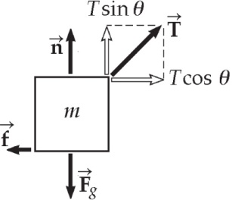P5.52** The force diagram is shown on the right. With motion impending,



and



**ANS. FIG. P5.52**

so 

To minimize T, we maximize 



Therefore, the angle where tension T is a minimum is



What is the tension at this angle? From above,





**P5.53**  We apply Newton’s second law to each of the three masses, reading the forces from ANS. FIG. P5.53:

 **[1]**

 **[2]**

 **[3]**

1. Substitute the value for *a* from [1] into [3] and solve for *T*:



Substitute for *A* from [2]:



(b) Solve [3] for *a* and substitute value of *T*:



(c) From [2],  Substitute the value of *T*:



(d) The acceleration of *m*1 is given by



**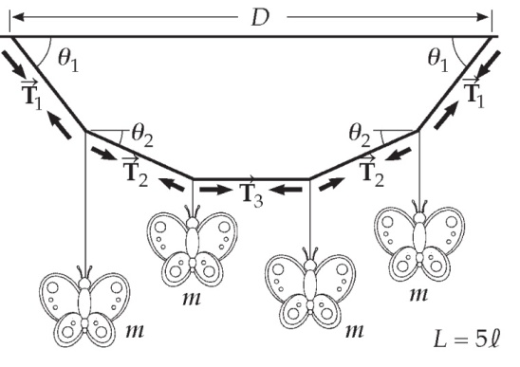P5.54** (a) Apply Newton’s second law   
to two points where butter-  
flies are attached on either   
half of mobile (the other half   
is the same, by symmetry).

 **[1]**

 **[2]**

**ANS. FIG. P5.54**

 **[3]**

 **[4]**

Substituting [4] into [2] for ,



Then



Substitute [3] into [1] for 



Substitute value of T1:



From equation [4],



(b) Divide [4] by [3]:



Substitute value of T3:



Then we can finish answering part (a):



(c) D is the horizontal distance between the points at which the two ends of the string are attached to the ceiling.



**P5.55** Throughout its up and down motion after release the block has

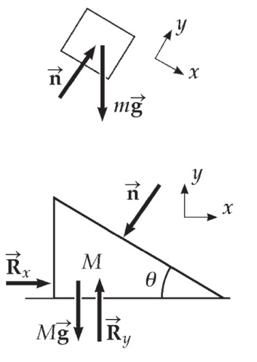 

Let  represent the force of table   
on incline. We have



**ANS. FIG. P5.102**



|  |
| --- |
| **ANSWERS TO QUICK-QUIZZES** |

**1.** (d)

**2.** (a)

**3.** (d)

**4.** (b)

**5. (i)** (c) **(ii)** (a)

**6.** (b)

**7.** (b) Pulling up on the rope decreases the normal force,

which, in turn, decreases the force of kinetic friction.

|  |
| --- |
| **ANSWERS TO EVEN-NUMBERED PROBLEMS** |

**P5.2** (a) force exerted by spring on hand, to the left; force exerted by spring on

wall, to the right (b) force exerted by wagon on handle, downward to the left; force exerted by wagon on planet, upward; force exerted by wagon on ground, downward (c) force exerted by football on player, downward to the right; force exerted by football on planet, upward (d) force exerted by small-mass object on large-mass object, to the left (e) force exerted by negative charge on positive charge, to the left (f) force exerted by iron on magnet, to the left

**P5.4** (a) –4.47 × 1015 m/s2; (b) +2.09 × 10–10 N

**P5.6** 1.59 m/s2 at 65.2° N of E

**P5.8** 

**P5.10** (a) ; (b) magnitude: , direction: 

**P5.12** 2.38 kN

**P5.14** (a–c) See free-body diagrams and corresponding forces in P5.14.

**P5.16** (a) See ANS. FIG. P5.16; (b) 1.03 N; (c) 0.805 N to the right

**P5.18** See P5.18 for complete derivation.

**P5.20** 8.66 N east

**P5.22** (a) See ANS FIG P5.22; (b) 3.57 m/s2; (c) 26.7 N; (d) 7.14 m/s

**P5.24** , , *B* is in tension and *A* is in compression.

**P5.26** The situation is impossible because maximum static friction cannot provide the acceleration necessary to keep the book stationary on the seat.

**P5.28** (a) 4.18; (b) Time would increase, as the wheels would skid and only kinetic friction would act; or perhaps the car would flip over.

**P5.30** (a) 0.404; (b) 45.8 lb

**P5.32** (a) See ANS. FIG. P5.32; (b) 2.31 m/s2, down for m1, left for m2, and up for m3; (c) T12 = 30.0 N and T23 = 24.2 N; (d) T12 decreases and T23 increases

**P5.34** (a) 48.6 N, 31. 7 N; (b) If P > 48.6 N, the block slides up the wall. If P < 31.7

N, the block slides down the wall; (c) 62.7 N, P > 62.7 N, the block cannot

slide up the wall. If P < 62.7 N, the block slides down the wall

**P5.36** (a) See P5.36 for complete solution; (b) 9.80 N, 0.580 m/s2

**P5.38** The situation is impossible because these forces on the book cannot produce the acceleration described.

**P5.40** (a) and (b) See P5.40 for complete derivation; (c) 3.56 N

**P5.42** (a) See ANS. FIG. P5.42(a); (b) ; (c) ; (d) the tension in a cord of negligible mass is constant along its length

**P5.44** (a) Nick and the seat, with total weight 480 N, will accelerate down and the child, with smaller weight 440 N, will accelerate up; (b) In P5.44, a rope tension of 250 N does not make the rope break. In part (a), the rope is strong enough to support tension 459 N. But now the tension everywhere in the rope is 480 N, so it can exceed the breaking strength of the rope.

**P5.46** (a) a1 = 2a2; (b) *a2* = 12.7 N (1.30 kg + 4*m*1)–1 down; (c) 9.80 m/s2 down; (d) a2 approaches zero; (e) T = 6.37 N; (f) yes

**P5.48** (a) The net force on the cushion is in a fixed direction, downward and

forward making angle tan21 (*F*/*mg*) with the vertical. Starting from rest, it will move along this line with (b) increasing speed. Its velocity changes in magnitude. (c) 1.63 m (d) It will move along a parabola. The axis of the parabola is parallel to the line described in part (a). If the cushion is thrown in a direction above this line, its path will be concave downward, making its velocity become more and more nearly parallel to the line over time. If the cushion is thrown down more steeply, its path will be concave upward, again making its velocity turn toward the fixed direction of its acceleration.

**P5.50** (a) n = (8.23 N) cos *θ*; (b) a = (9.80 m/s2) sin *θ*; (c) See ANS. FIG P5.50;   
(d) At 0˚, the normal force is the full weight, and the acceleration is zero. At 90˚ the mass is in free fall next to the vertical incline.

**P5.52** The situation is impossible because at the angle of minimum tension, the tension exceeds 4.00 N

**P5.54** (a) , ;

(b) ;

(c) See P5.54 for complete explanation